Institute of Information Technology (IIT)

Jahangirnagar University



**Lab Report: 03**

Submitted by:

Name: Md. Shakil Hossain

Roll No: 2023

Lab Date: 14-June-2023 Submission Date: 22-June-2023

# Exercise 01:

**Lab Report: Day 03**

**Problem Name**: Write a Python program to find the sum of all the elements in a list.

# Code:

list=[3,5,4,7,8,1,0,8,4]

total=0

for i in list: total+=i

print(f"Sum of list : {total}")

**Output:**



# Exercise 02:

**Problem Name**: Write a Python program to find the largest, smallest, second largest, and second smallest elements in a list.

# Code:

list=[3,5,4,7,9,1,0,8,4]

list.sort()

print(f"The list : {list}") print(f"Largest : {list[-1]}")

print(f"Smallest : {list[0]}") print(f"Second Largest : {list[-2]}") print(f"Second Smallest : {list[1]}")

**Output:**

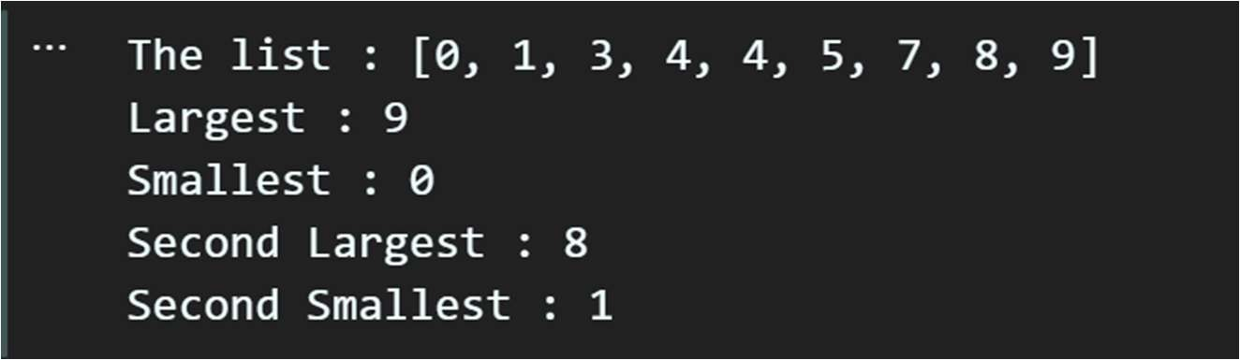

**Problem Name**: Write a Python program to count the number of occurrences of each character in a string.

# Code:

def charcount(string): count={}

for i in string: if i in count:

count[i]+=1 else:

count[i]=1 return count

string="Beekeepers keep bees" chars=charcount(string)

for char in chars:

print(f"{char} :: {chars[char]}")

**Output:**

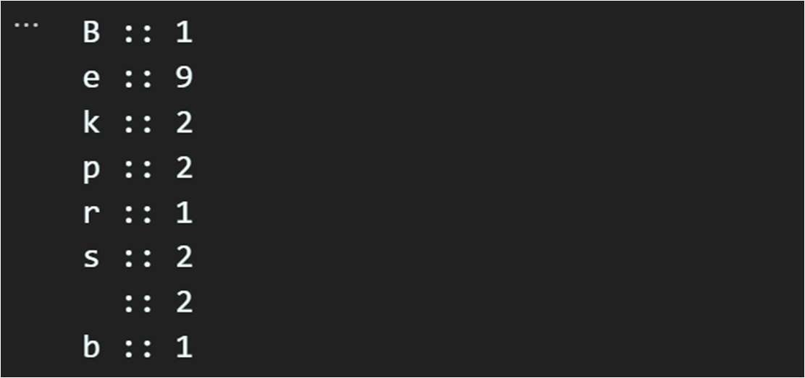

# Exercise 04:

**Problem Name**: Write a Python program to create a tuple with elements from a list and print it.

# Code:

def maketuple(list): tup=tuple(list) return tup

list=[3,5,2,4,6,7,8,5,34]

tuple=maketuple(list) print(tuple)

**Output:**



**Problem Name**: Write a Python function that takes a list of numbers as input and returns the largest sum of non-adjacent numbers.

# Code:

def nonadjecntsum(nums): if not nums:

return 0

n = len(nums) if n <= 2:

return max(nums)

max_sum = [0] * n max_sum[0] = nums[0]

max_sum[1] = max(nums[0], nums[1])

for i in range(2, n):

max_sum[i] = max(max_sum[i-1], max_sum[i-2] + nums[i]) return max_sum[n-1]

my_list = [1,3,7,2, 4, 6, 2,9, 5]

result = nonadjecntsum(my_list)

print("Largest sum of non-adjacent numbers:", result)

**Output:**



# Exercise 06:

**Problem Name**: Write a Python program to remove duplicates from a list and return the resultant list.

# Code:

def dupremove(list): list1=[]

for i in list:

if i not in list1: list1.append(i)

print(f"Duplicates removed list : {list1}")

list = [7,4,7,8,2,0,8,1,0,4,5,6,8,2,9]

dupremove(list)

**Output:**



**Problem Name**: Write a Python program to find the common elements between two lists and return the resultant list.

# Code:

def common(list1,list2): result=[]

for i in list1: if i in list2:

result.append(i) print(f"common elements : {result}")

list1=[1,4,6,8,0,5]

list2=[7,5,1,9,8,4]

common(list1,list2)

**Output:**



# Exercise 08:

**Problem Name**: Write a Python program to find the first n Fibonacci numbers using recursion.

# Code:

def fibonacci(n): if n==0:

return elif n==1:

return [0] elif n==2:

return [0,1] else:

seq=fibonacci(n-1) seq.append(seq[-1]+seq[-2]) return seq

n=15

fib=fibonacci(n)

print(f"First {n} Fibonacci numbers : {fib}")

**Output:**



**Problem Name**: Write a Python function to replace all occurrences of a substring in a string.

# Code:

string = "Good morning teacher." substring="teacher"

replace= "students" rep=string.replace(substring,replace) print(rep)

**Output:**



# Exercise 10:

**Problem Name**: Write a function to add a key-value pair to a dictionary in Python

# Code:

def addtodic(dictionary,key,value): dictionary[key]=value

return

dictionary={'name':'Tokee',

'roll':'2022'}

key="age" value=23

addtodic(dictionary,key,value) print(dictionary)

**Output:**



# Exercise 11:

**Problem Name**: Write a function to remove a key from a dictionary in Python

# Code:

def delete(dictionary,key): dictionary.pop(key) return

dictionary={'name':'Tokee' , 'roll':'2022' , 'age':23} key="roll"

delete(dictionary,key) print(dictionary)

**Output:**

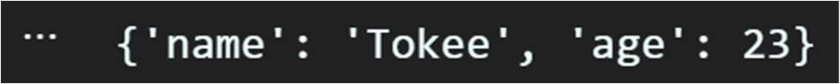

**Problem Name**: Write a function to reverse a list of numbers.

# Code:

def reverse(list): return list[::-1]

list=[1,2,3,4,5,6,7]

print(f"Reversed list : {reverse(list)}")

**Output:**



# Exercise 13:

**Problem Name**: Write a Python program to find and print the key with the maximum value in a dictionary.

# Code:

def maxkey(dictionary): max_value = 0 max_key = None

for key, value in dictionary.items(): if value > max_value:

max_value = value max_key = key

return max_key

dictionary = {'a': 10, 'b': 30, 'c': 20} key = maxkey(dictionary)

print(f"Key with maximum value : {key}")

**Output:**



**Problem Name**: Write a Python program to merge two dictionaries and create a new dictionary.

# Code:

def marge(dict1, dict2): dict={} dict.update(dict1) dict.update(dict2) return dict

dict1 = {'a': 4, 'b': 7, 'c':10}

dict2 = {'x': 3, 'y': 4, 'z':5}

merged_dict = marge(dict1, dict2) print(f"Merged dictionary : {merged_dict}" )

**Output:**



# Exercise 15:

**Problem Name**: Given a list of dictionaries, you want to sort them based on a specific key 'age' in each dictionary. Write a lambda function as the key parameter in the sorted() function to achieve this.

# Code:

people = [

{'name': 'Alice', 'age': 25},

{'name': 'Bob', 'age': 30},

{'name': 'Charlie', 'age': 20}

]

sort=sorted(people,key=lambda x:x['age']) print(sort)

**Output:**

